Declaration
I, Yang Tang, declare that this assignment, titled FIT5032 A1.1, is my own original work and has not been copied from any other source except where explicitly acknowledged. I have not engaged in plagiarism, collusion, or any other form of academic misconduct in the preparation and submission of this assignment. All sources of information and data used in this assignment have been properly cited and referenced in accordance with the prescribed guidelines. I have not used unauthorized assistance in the preparation of this assignment and have not allowed any other student to copy my work. I am aware that any breach of academic integrity may result in disciplinary action as per the policies of Monash University, which may include failing this assignment or the course, and further academic penalties.


Signature: ________________________ Date: _________16/08/2026___________

Github Check
Enter your Github details here.
Github Username  Enter your username here | TophLumina
Repository Shared?  Have you started and shared your assignment repository with your tutor yet? | No

Self-Evaluation
Rate your performance for each criteria. Put a ✅(tick) in the box where you think your work belongs.

Criteria | Exceeds Expectations | Meets Expectations | Needs Improvement | Fail to meet expectations
Executive Summary |  | ✅
User Personas |  | ✅
Sitemap | ✅
Wireframes/Low-fidelity Prototype | ✅

Section 1: Executive Summary
What Can I Plant? is a proposed web application for Pocket Habitat Melbourne, a fictional not-for-profit organisation that promotes practical urban greening, biodiversity awareness and environmental learning across Melbourne. The project responds to a simple barrier to participation: many residents want to grow plants or support local biodiversity but have limited outdoor space, limited horticultural knowledge, or difficulty identifying reliable and locally relevant information. The client therefore aims to make small-scale gardening more approachable, encourage responsible plant choices, connect people with community environmental activities, and support families and schools in using gardening as a practical learning experience.

The primary audience consists of three groups: beginner urban gardeners living in apartments or homes with limited planting space; parents seeking accessible environmental activities to complete with children; and primary-school teachers or sustainability coordinators looking for reliable planting and biodiversity resources. Their needs overlap around clear guidance, appropriate plant selection and local information, while differing in the depth, purpose and educational context in which that information is used.

The application will centre on a searchable Plant Guide that helps users discover suitable plants according to available space, sunlight, maintenance level and environmental value. Supporting sections will provide small-space and seasonal gardening guides, responsible plant and seed sourcing information, education about invasive and threatened flora, local workshops and community planting events, and a blog-based Community Stories area where users can read experiences and leave moderated comments.

Original research informed this content structure. Sustainable Gardening Australia demonstrates how a not-for-profit can combine practical sustainable-gardening advice with community resources and gardening stories. CERES provides locally relevant seasonal advice for Melbourne and explicitly addresses gardening in backyards, balconies and other small spaces. Junior Landcare demonstrates the value of structured biodiversity and gardening activities for children and educators. Victorian Government resources also show the importance of responsible indigenous plant sourcing and reliable environmental information.

The primary goal of What Can I Plant? is therefore not to become a commercial nursery or a professional botanical database, but to provide a concise pathway from “I want to grow something” to informed planting, environmental learning and local community participation.

Section 2: Sitemap
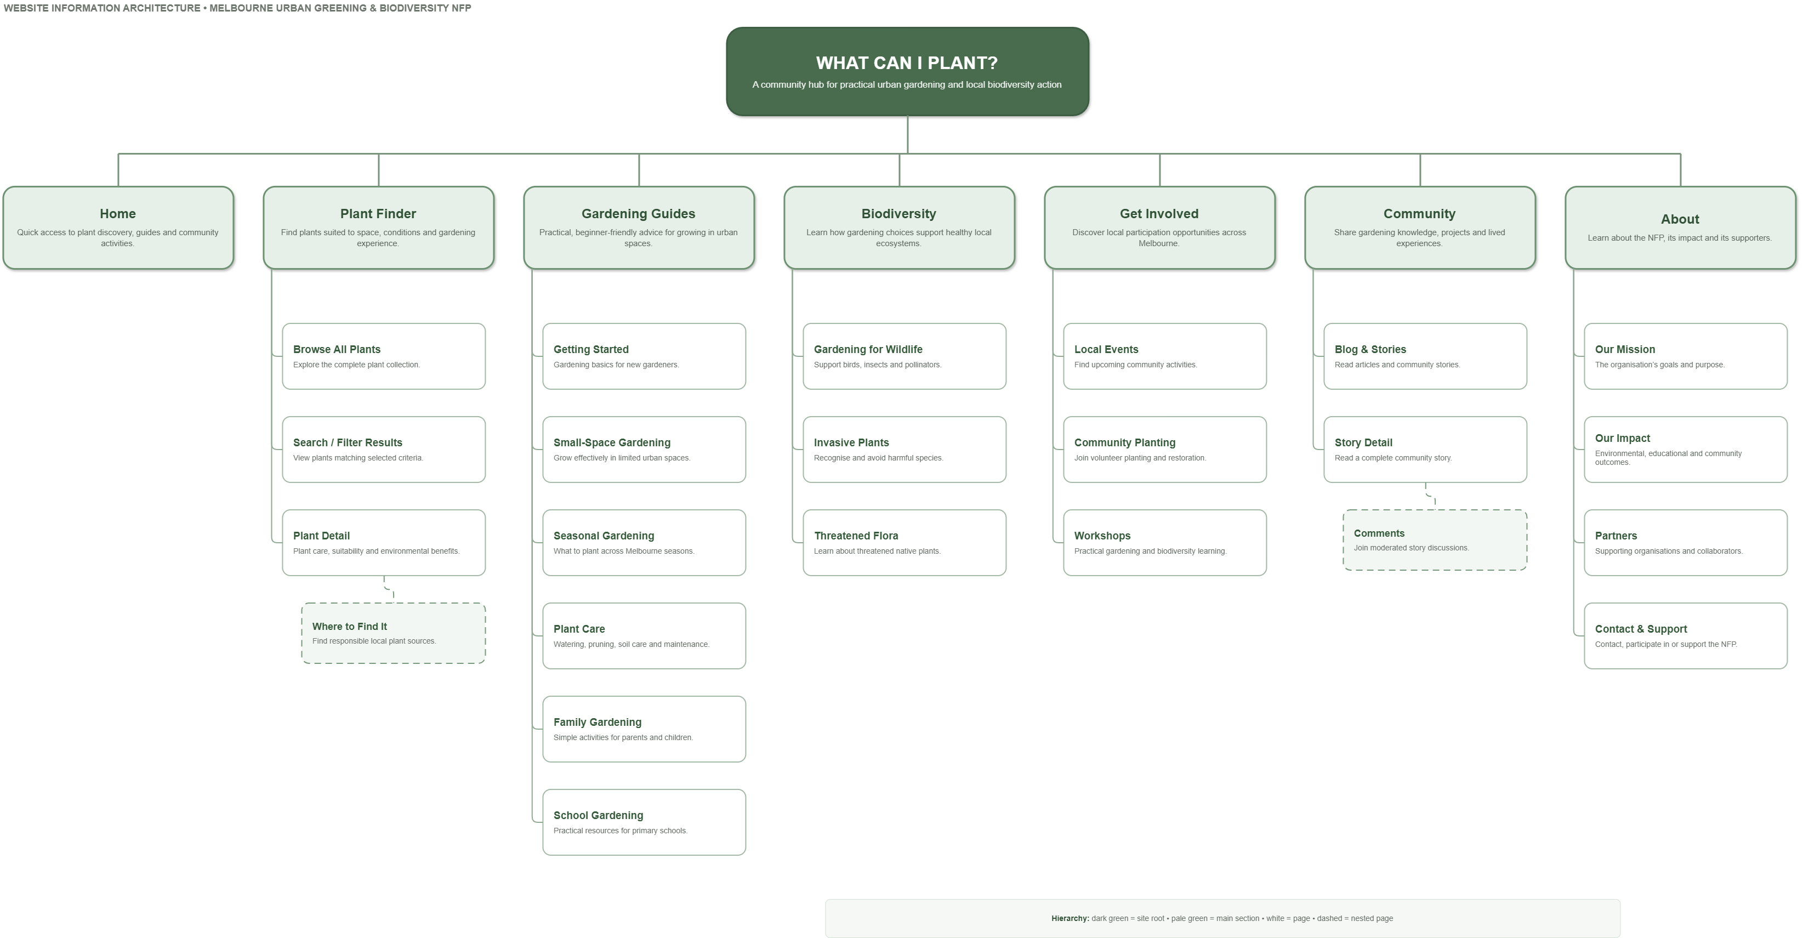

Section 3: User Personas
Maya Chen: Beginner Small-Space Gardener

Maya is a 24-year-old postgraduate student who rents a one-bedroom apartment in Carlton, Melbourne. She has a small north-facing balcony and no private garden. She is interested in sustainability and would like to add greenery to her apartment, but her gardening experience is limited to a few indoor plants. Her budget is modest, and she prefers plants that are inexpensive, resilient and easy to maintain around study and part-time work.

Maya’s main goal is to understand what she can realistically grow in a small space without wasting money on unsuitable plants. She needs recommendations based on balcony conditions, sunlight, container size, season and maintenance difficulty. She is also interested in native flowering plants that can support bees and other urban wildlife, but finds scientific plant databases overwhelming and general gardening websites insufficiently specific to Melbourne.

Her main pain points are information overload, conflicting online advice and uncertainty about where plants or seeds should be sourced responsibly. She may also unknowingly choose an invasive species or a plant that will quickly outgrow its container.

What Can I Plant? supports Maya through a searchable Plant Guide with simple filters for space, light, difficulty and biodiversity value. Plant profiles explain care requirements in accessible language and link to responsible local sourcing information. Small-space and seasonal guides give her a clear starting point, while community stories provide practical examples from people gardening under similar constraints.

Daniel Morgan: Parent and Home Learning Facilitator

Daniel is a 38-year-old parent living in Coburg with two children aged seven and ten. He works full-time in administration and has a small courtyard rather than a large garden. He is not a gardening enthusiast, but he regularly looks for inexpensive weekend activities that are educational, practical and engaging for his children. He wants them to understand where plants come from, recognise local wildlife and develop positive habits around environmental responsibility.

Daniel needs short, achievable gardening activities that do not require specialist equipment or extensive preparation. He would like to identify child-friendly plants, create a small pollinator garden, grow a plant from seed, and occasionally attend a nearby community planting day or environmental workshop. He values reliable explanations because he wants to answer his children’s questions accurately.

His pain points include limited time, uncertainty about which online resources are appropriate for beginners, and gardening instructions that assume too much prior knowledge. Long technical articles are unlikely to hold his attention, and failed projects may discourage his children.

What Can I Plant? provides beginner and family gardening guides organised around manageable projects, with relevant plants linked directly from each activity. Biodiversity pages explain topics such as pollinators, invasive plants and threatened flora in approachable terms. The local events section allows Daniel to discover family-suitable workshops and planting activities, extending home learning into community participation.

Rachel Williams: Primary-School Sustainability Coordinator

Rachel is a 43-year-old Year 4 teacher and sustainability coordinator at a Melbourne primary school. She helps organise environmental activities alongside her teaching workload and works with limited funding, time and gardening expertise. Her school has several raised beds and a small unused outdoor area that could support a native or wildlife-friendly garden.

Rachel’s goals are to create practical learning activities connected to biodiversity, plant lifecycles and environmental responsibility; select plants that are manageable in a school environment; and find local programs or community events that can extend classroom learning. She requires information that is credible, easy to prepare and understandable for primary-school students. She also wants examples of projects completed by other families, schools or community groups.

Her pain points are fragmented resources, uncertainty about plant suitability, limited preparation time and the difficulty of converting professional environmental information into classroom-ready activities. She must also avoid plants that are inappropriate, invasive, hazardous or excessively demanding to maintain.

What Can I Plant? gives Rachel a dedicated collection of school gardening and biodiversity resources supported by the same structured Plant Guide used elsewhere in the application. She can compare low-maintenance plants, review environmental warnings, locate suitable learning activities and discover community events. Community Stories can showcase school projects and allow educators or gardeners to exchange moderated, topic-specific advice without requiring a complex social-network platform.

Section 4: Wireframes/Low-fidelity prototype

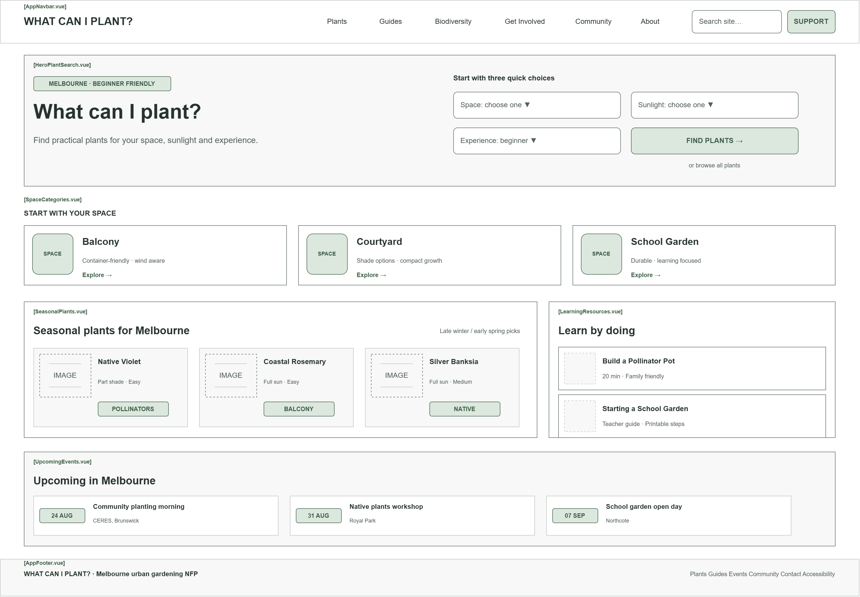
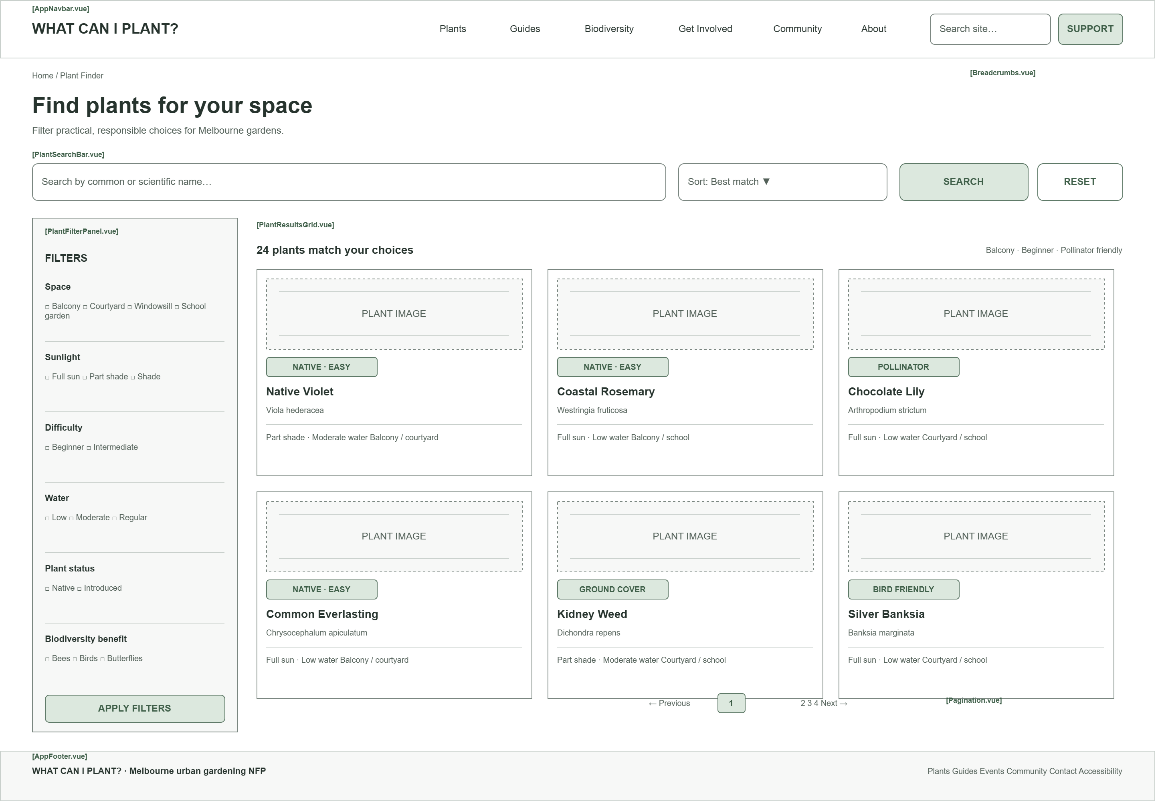
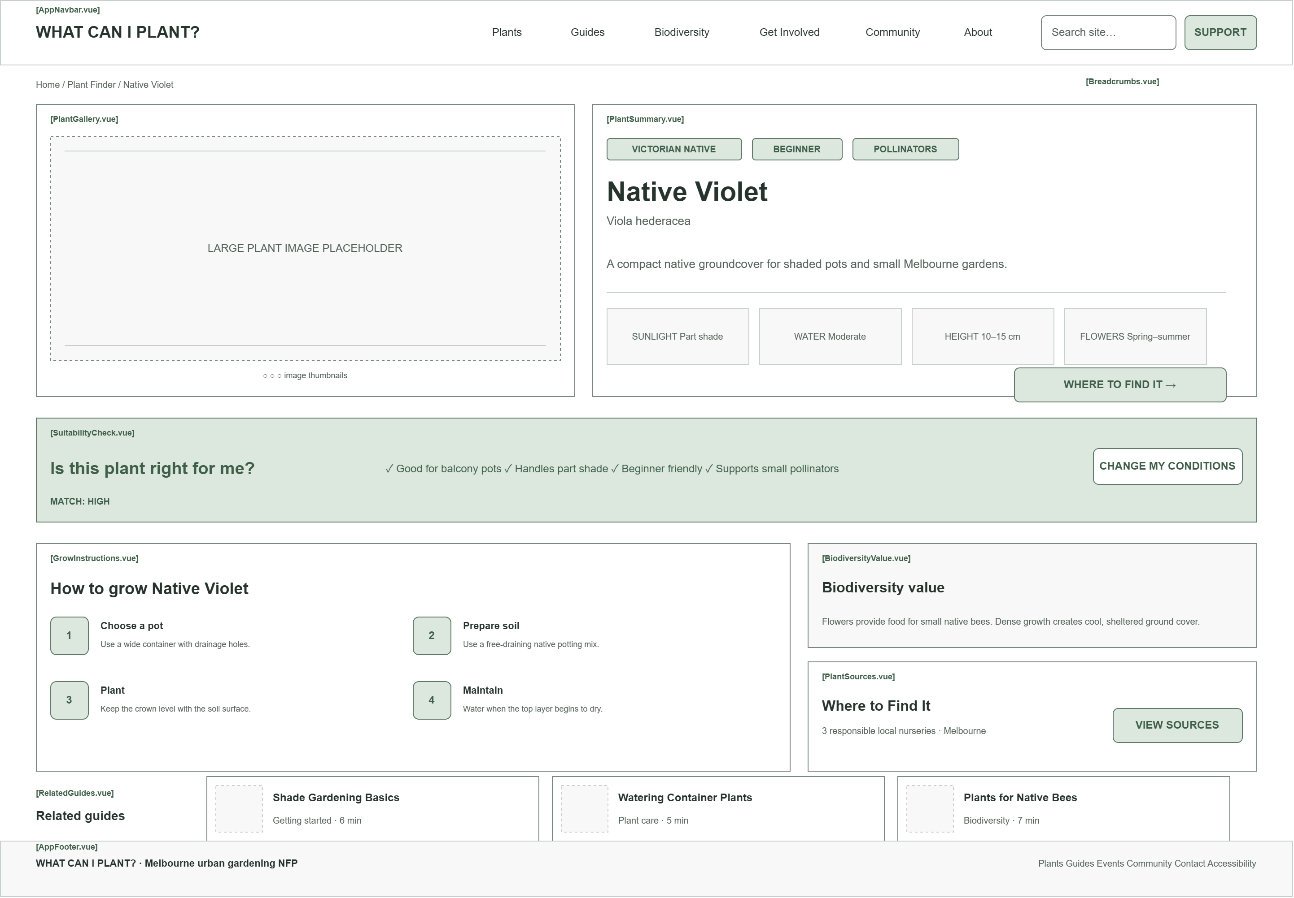
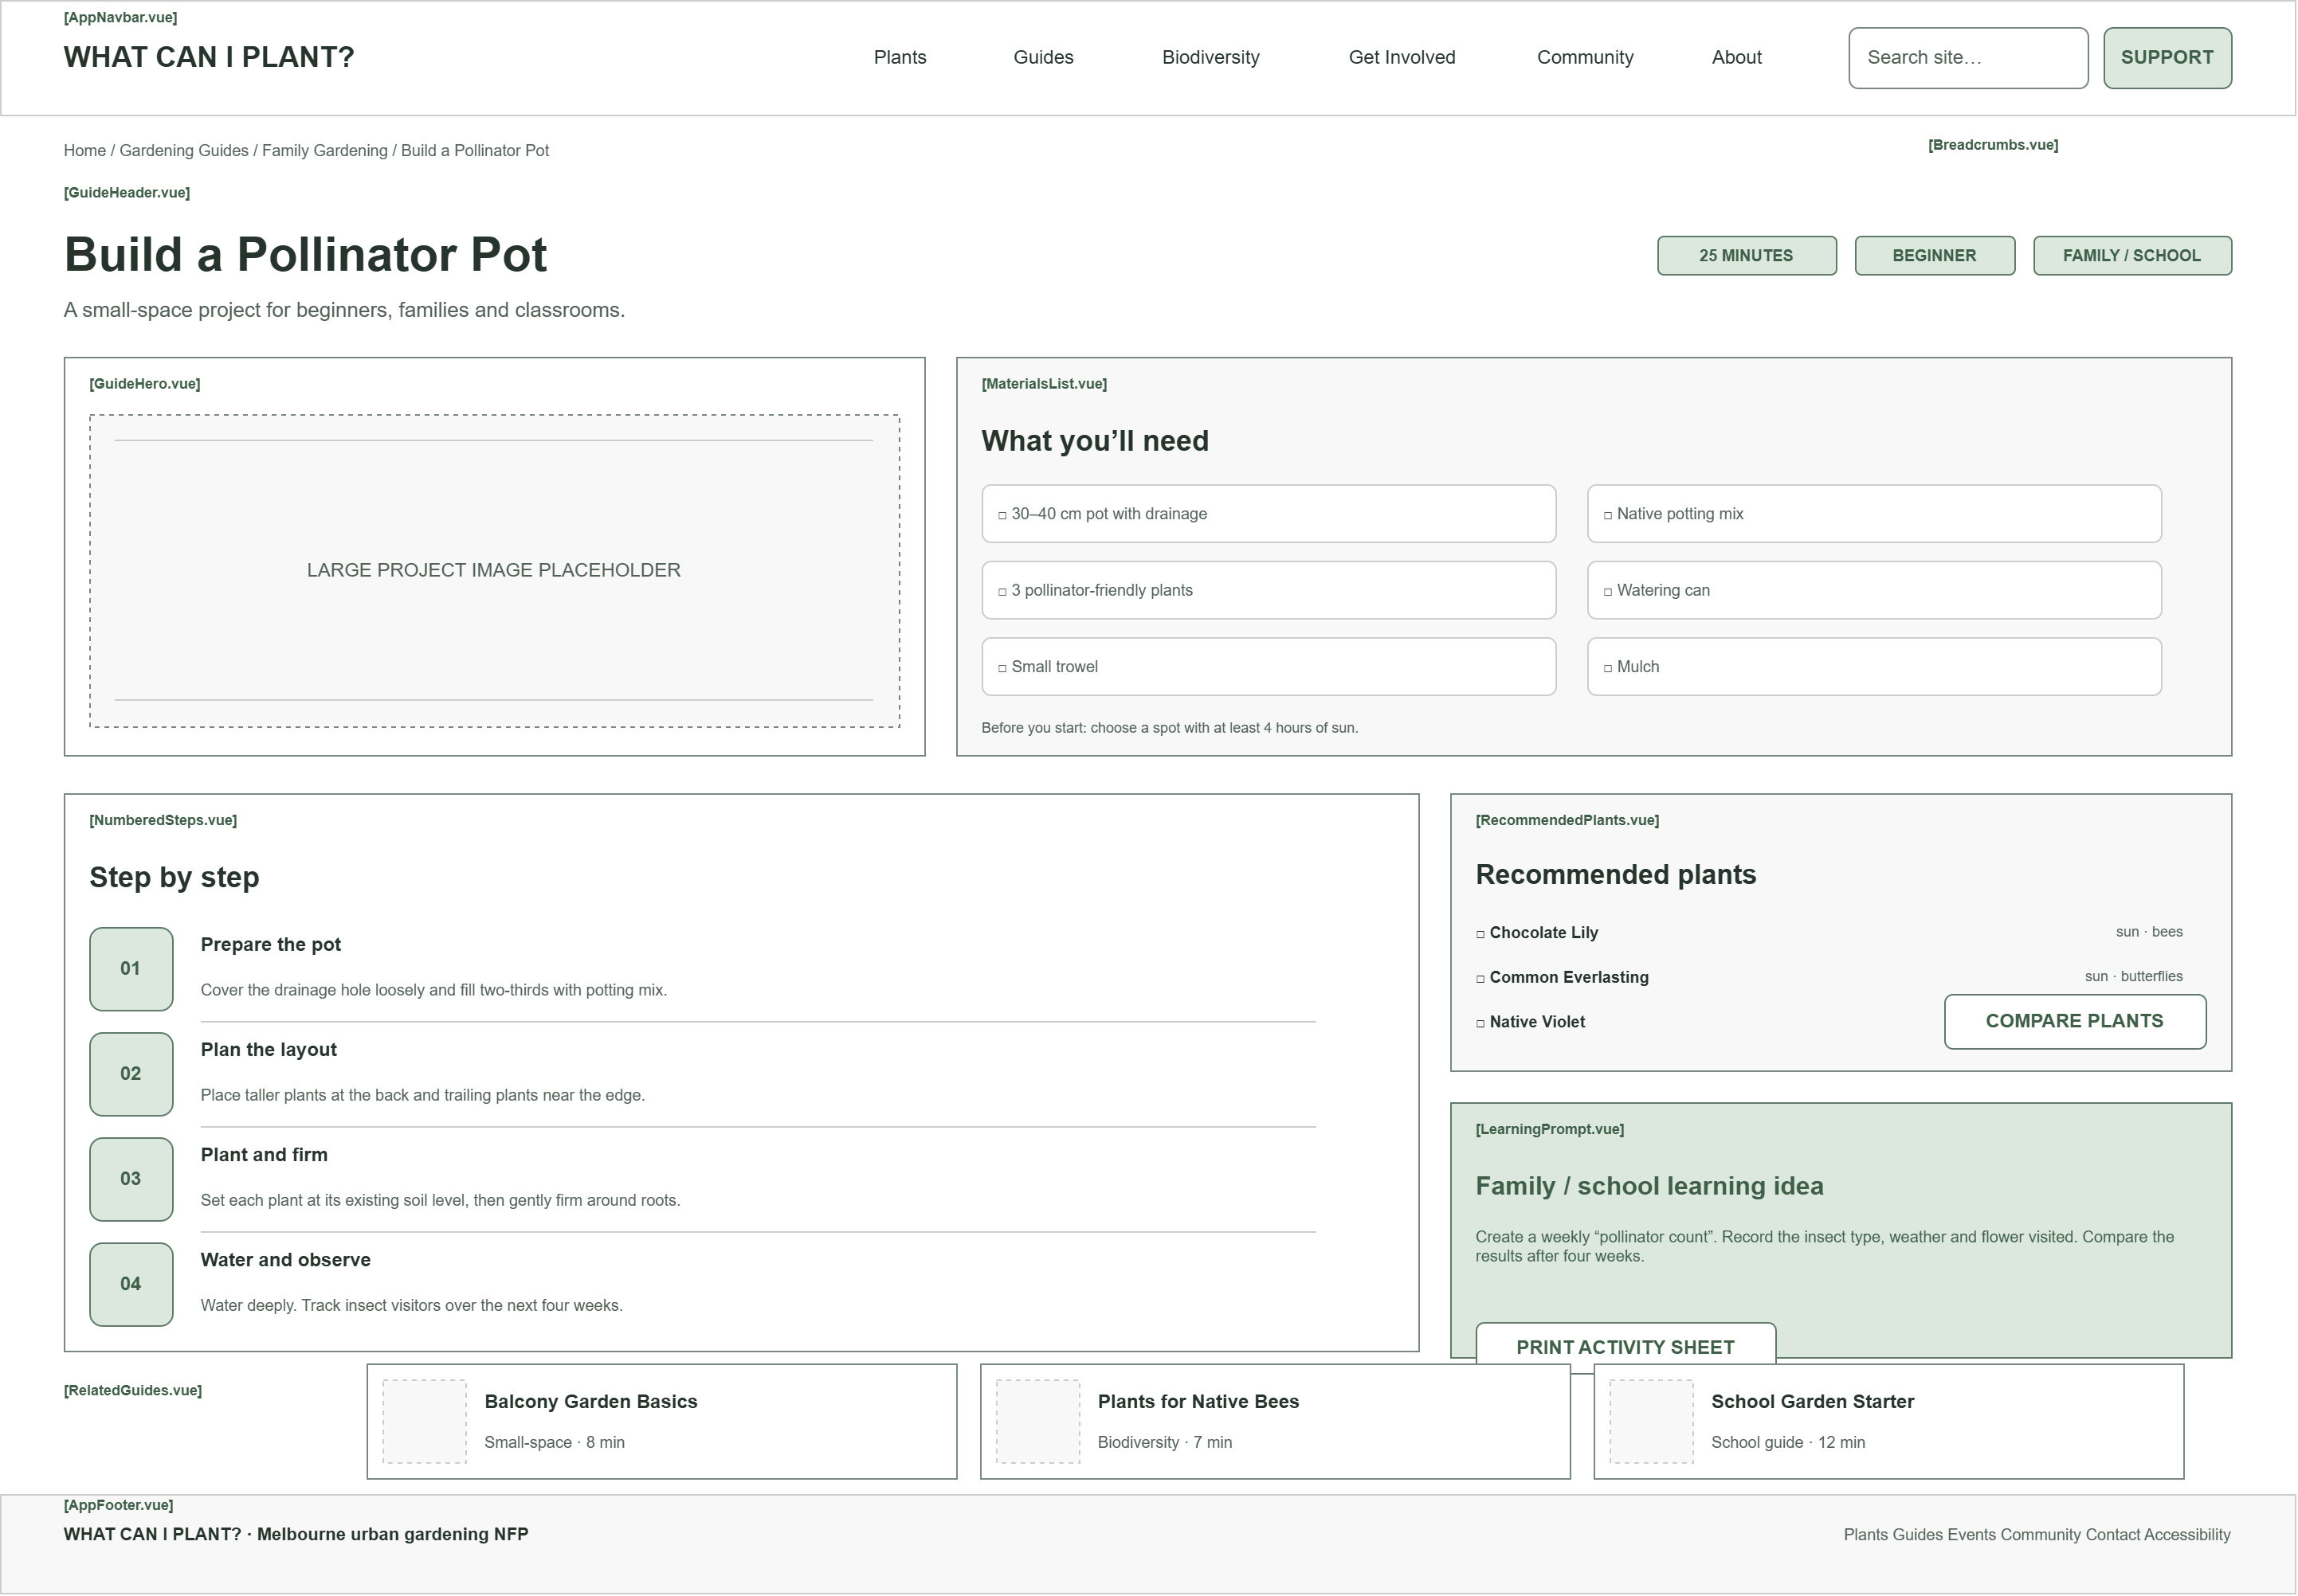
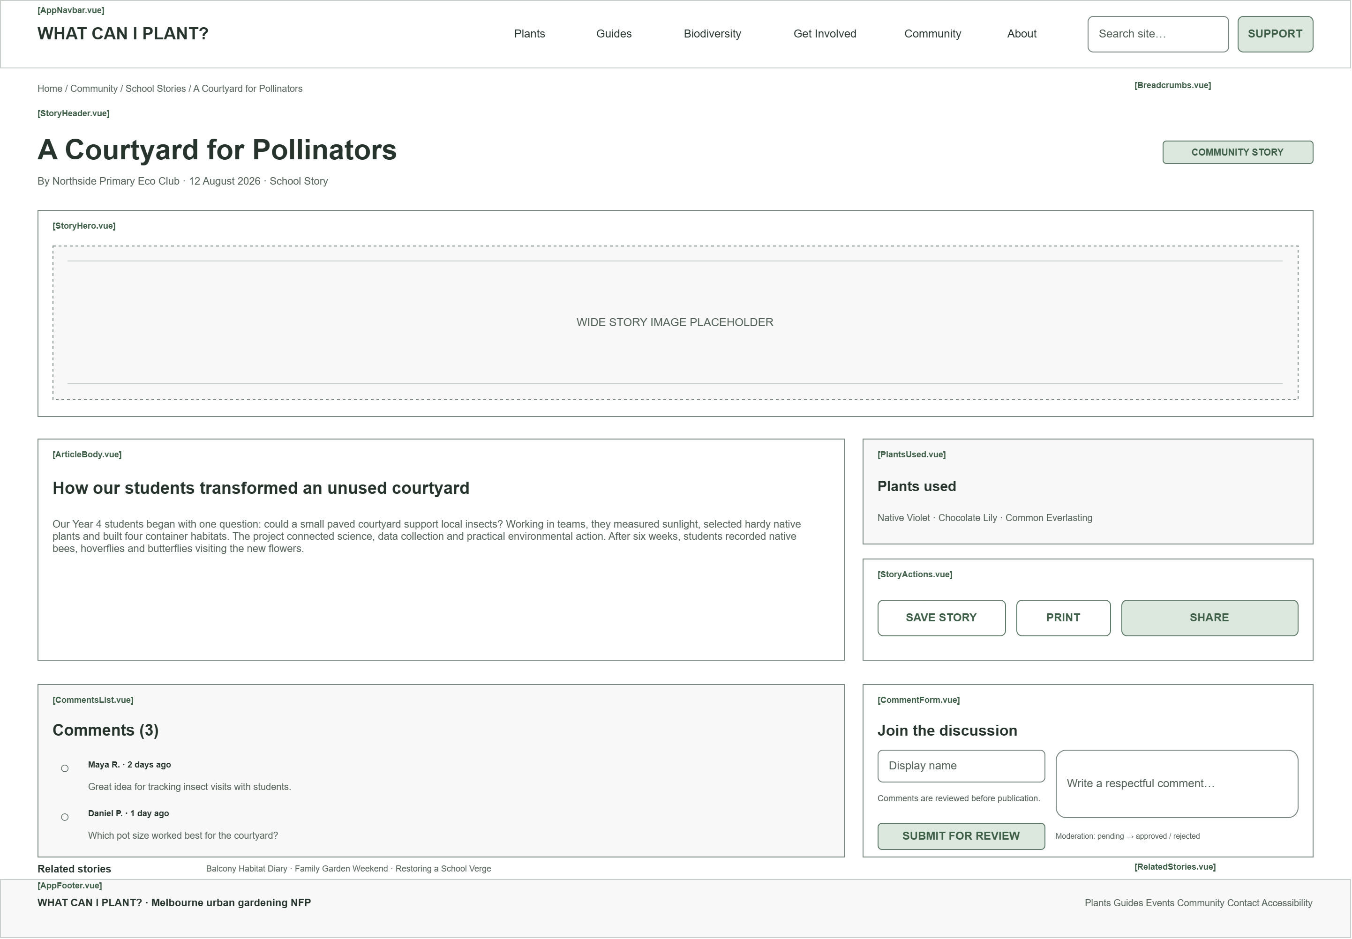

Declaration: Additional Help
Any tools that you used (including Gen AI or existing code reuse) must be declared here.

Note: GenAI is not allowed for coding purposes in any assignment,

However, you may use GenAI for brainstorming, problem solving and learning. You need to declare all such uses here. One row per help used. More details on how to acknowledge the use of Gen AI can be found here.

Name | Description
Chat GPT 5.6 Sol | I used ChatGPT(ChatGPT) to discuss the idea about building web pages specified about guiding user to plant something in limited space. And, some possible future Impl framework (Vue components tags) under that topic.
Chat GPT 5.6 Sol | I also used ChatGPT (ChatGPT) for asking Draw.IO tutorials and advice about format/colour of the layout scratch.

